**Practice 6**

1. Create, compile, and invoke the ADD_JOB procedure and review the results.

* + - 1. Create a procedure called ADD_JOB to insert a new job into the JOBS table. Provide the ID and job title using two parameters.
      2. Compile the code, and then invoke the procedure with IT_DBA as the job ID and Database Administrator as the job title. Query the JOBS table and view the results.

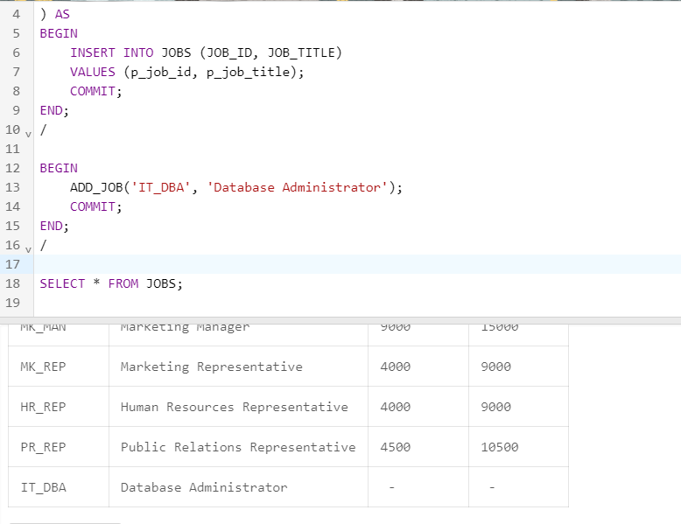

CREATE OR REPLACE PROCEDURE ADD_JOB (

p_job_id JOBS.JOB_ID%TYPE,

p_job_title JOBS.JOB_TITLE%TYPE

) AS

BEGIN

INSERT INTO JOBS (JOB_ID, JOB_TITLE)

VALUES (p_job_id, p_job_title);

COMMIT;

END;

/

BEGIN

ADD_JOB('IT_DBA', 'Database Administrator');

COMMIT;

END;

/

SELECT * FROM JOBS;

* + - 1. Invoke your procedure again, passing a job ID of ST_MAN and a job title of Stock Manager. What happens and why?

ORA-00001: unique constraint

(SQL_TTPAYIEHJWTLFJILYAFCOFWDI.JOB_ID_PK) violated

2. Create a procedure called UPD_JOB to modify a job in the JOBS table.

* + - 1. Create a procedure called UPD_JOB to update the job title. Provide the job ID and a new title using two parameters. Include the necessary exception handling if no update occurs.
      2. Compile the procedure. Invoke the procedure to change the job title of the job ID IT_DBA to Data Administrator. Query the JOBS table and view the results.

a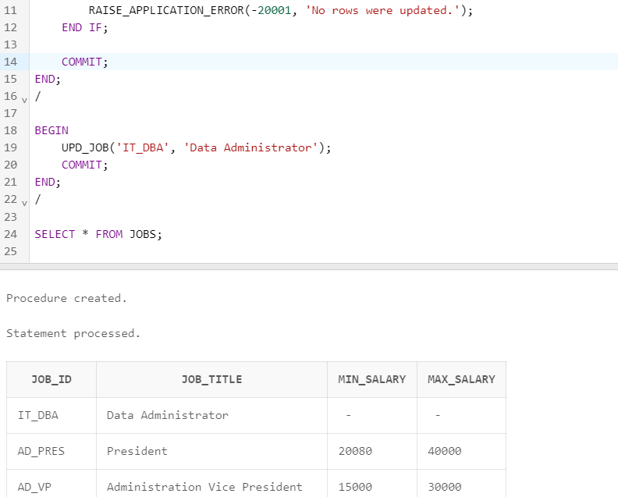

CREATE OR REPLACE PROCEDURE UPD_JOB (

p_job_id JOBS.JOB_ID%TYPE,

p_new_job_title JOBS.JOB_TITLE%TYPE

) AS

BEGIN

UPDATE JOBS

SET JOB_TITLE = p_new_job_title

WHERE JOB_ID = p_job_id;

IF SQL%ROWCOUNT = 0 THEN

RAISE_APPLICATION_ERROR(-20001, 'No rows were updated.');

END IF;

COMMIT;

END;

/

BEGIN

UPD_JOB('IT_DBA', 'Data Administrator');

COMMIT;

END;

/

SELECT * FROM JOBS;

* + - 1. Test the exception handling section of the procedure by trying to update a job that does not exist. You can use the job ID IT_WEB and the job title Web Master.

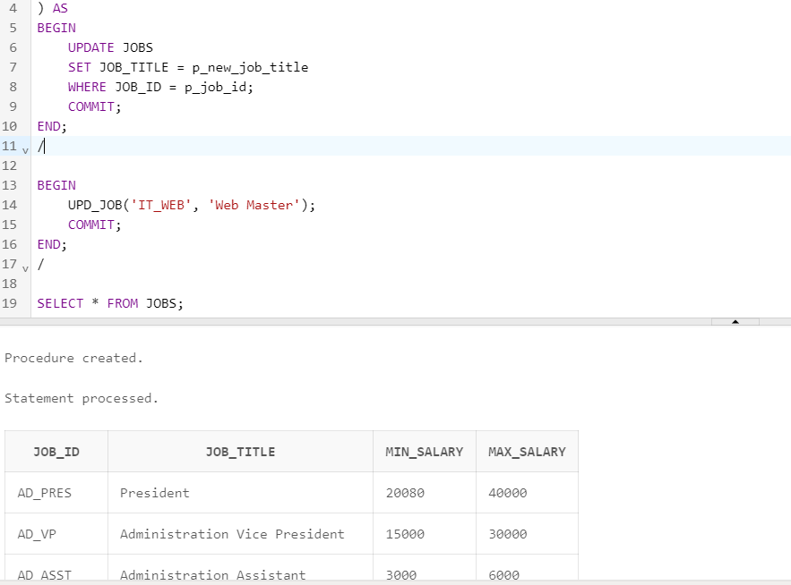

CREATE OR REPLACE PROCEDURE UPD_JOB (

p_job_id JOBS.JOB_ID%TYPE,

p_new_job_title JOBS.JOB_TITLE%TYPE

) AS

BEGIN

UPDATE JOBS

SET JOB_TITLE = p_new_job_title

WHERE JOB_ID = p_job_id;

COMMIT;

END;

/

BEGIN

UPD_JOB('IT_DBA', 'Data Administrator');

COMMIT;

END;

/

SELECT * FROM JOBS;

3. Create a procedure called DEL_JOB to delete a job from the JOBS table.

* + - 1. Create a procedure called DEL_JOB to delete a job. Include the necessary exception handling code if no job is deleted.
      2. Compile the code; invoke the procedure using the job ID IT_DBA. Query the JOBS table and view the results.

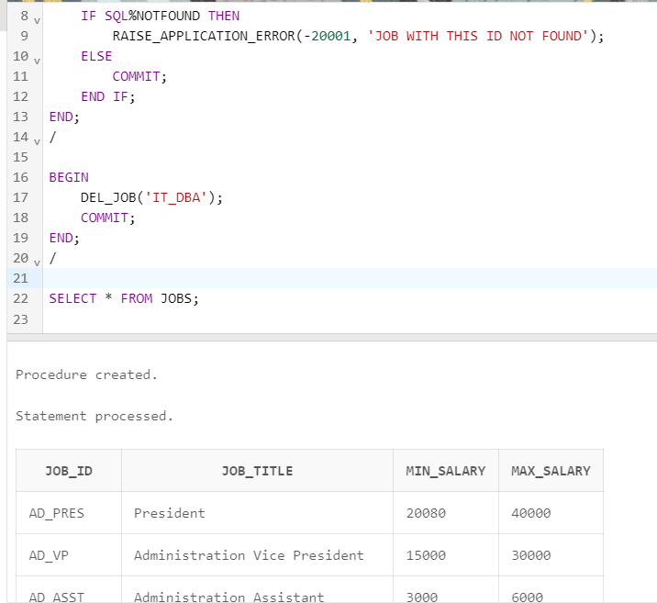

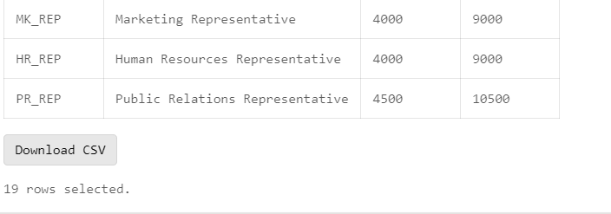

CREATE OR REPLACE PROCEDURE DEL_JOB (

p_job_id JOBS.JOB_ID%TYPE

) AS

BEGIN

DELETE FROM JOBS

WHERE JOB_ID = p_job_id;

IF SQL%NOTFOUND THEN

RAISE_APPLICATION_ERROR(-20001, 'No job found with the specified job ID');

ELSE

COMMIT;

END IF;

END;

/

BEGIN

DEL_JOB('IT_DBA');

COMMIT;

END;

/

SELECT * FROM JOBS;

* + - 1. Test the exception handling section of the procedure by trying to delete a job that does not exist. Use the IT_WEB as the job ID. You should get the message that you included in the exception handling section of the procedure as the output.

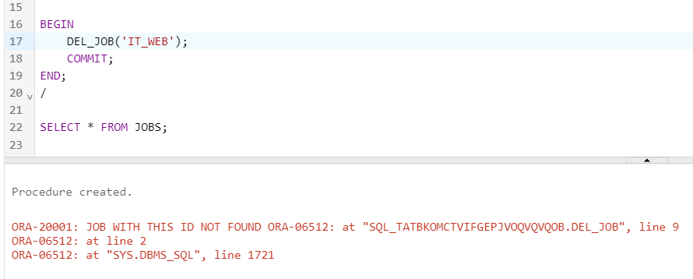

4. Create a procedure called GET_EMPLOYEE to query the EMPLOYEES table, retrieving the salary and job ID for an employee when provided with the employee ID.

a. Create a procedure that returns a value from the SALARY and JOB_ID columns for a specified employee ID. Compile the code and remove syntax errors, if any.

b. Create an anonymous block and call the procedure using variables for the two OUT parameters – one for the salary and the other for the job ID. Display the salary and job ID for employee ID 120.

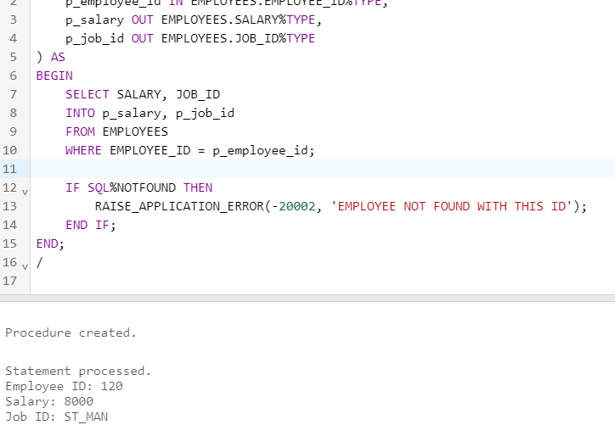

1. Invoke the procedure again, passing an EMPLOYEE_ID of 300. What happens and why?

